

The document
title goes here
Subheading goes here
15-10-2025
15-10-2025

Quick Guide

Paragraph styles
Use style templates for the different paragraph formats. Select the paragraph and choose a style.
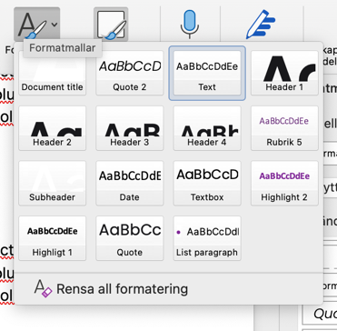

Pasting text into the document

Option 1
When pasting text from an external document, use the shortcut Ctrl + Alt + V to preserve the correct formatting.

Option 2
Select the pasted text and click Clear All Formatting.


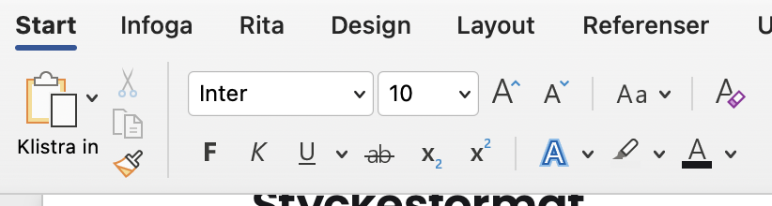

Using quote modules
Select all three text blocks and all three background blocks in the module, then copy or drag the entire module to the desired location. Enter your text and adjust the size of the background blocks by selecting and dragging the edges.
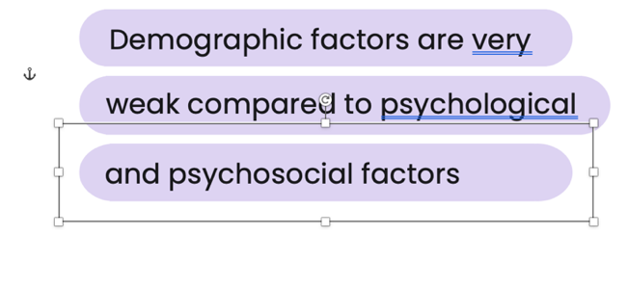
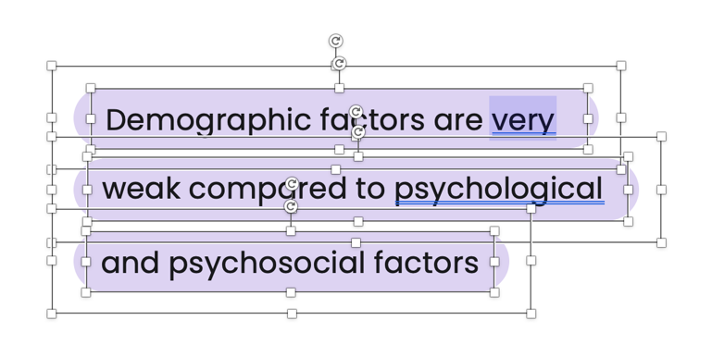

First header goes here
Lorem ipsum dolor sit amet. Est sint nihil qui repellat quia sed officiis architecto a voluptatem Quis! Qui voluptatem alias id amet fuga in aliquam quae. Ea illo aliquid aut voluptas eveniet sed repellendus dignissimos hic doloremque pariatur est nihil nihil At voluptate voluptas. Et deserunt officiis est distinctio numquam aut

Secondary header goes here
Lorem ipsum dolor sit amet. Est sint nihil qui repellat quia sed officiis architecto a voluptatem Quis! Qui voluptatem alias id amet fuga in aliquam quae. Ea illo aliquid aut voluptas eveniet sed repellendus dignissimos hic doloremque pariatur est nihil nihil At voluptate voluptas. Et deserunt officiis est distinctio numquam aut aliquam iusto qui ducimus galisum.

Tertiary header goes here
Lorem ipsum dolor sit amet. Est sint nihil qui repellat quia sed officiis architecto a voluptatem Quis! Qui voluptatem alias id amet fuga in aliquam quae. Ea illo aliquid aut voluptas eveniet sed repellendus dignissimos hic doloremque pariatur est nihil nihil At voluptate voluptas. Et deserunt officiis est distinctio numquam aut aliquam iusto qui ducimus galisum.

Example of a list paragraph
- This is a list paragraph
- This is a list paragraph
- This is a list paragraph
- This is a list paragraph

Demographic factors are very


weak compared to psychological
and psychosocial factors
Demographic factors are very weak compared to psychological and psychosocial factors
Demographic factors are very weak compared to psychological and psychosocial factors
Demographic factors are very weak compared to psychological and psychosocial factors
Demographic factors are very weak compared to psychological and psychosocial factors

























